## **Task 1. Retrieve employee device data**

In this task, you need to obtain information on employee devices because your team needs to update them. The information you need is in the machines table in the organization database.

**First**, you need to retrieve all the information about the employee devices.

1. Run the following query to select all device information from the machines table:

SELECT *

FROM machines;

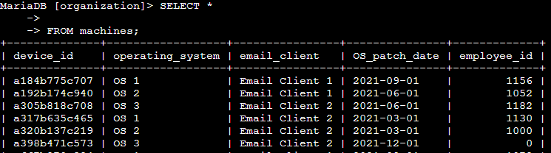

**Next**, you want to focus on the email client running on various devices.

1. Run the following query to select only the device_id and email_client columns from the machines table. Replace X with device_id and Y with email_client:

**SELECT device_id, email_client FROM machines;**

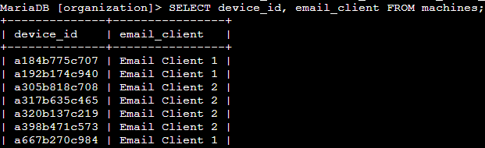

1. Complete the query to return only the device_id, operating_system, and OS_patch_date columns from the machines table. Replace X, Y, and Z with the columns that you need to return:

**SELECT device_id, operating_system, OS_patch_date FROM machines;**

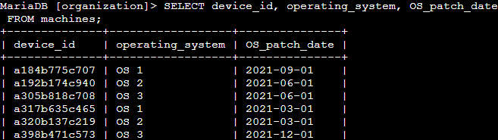

## 

## **Task 2. Investigate login activity**

In this task, you need to analyze the information from the log_in_attempts table to determine if any unusual activity has occurred.

First, you need to investigate the locations where login attempts were made to ensure that they’re in expected areas (the United States, Canada, or Mexico).

1. Write a SQL query to select the event_id and country columns from the log_in_attempts table.

**SELECT event_id, country FROM log_in_attempts;**

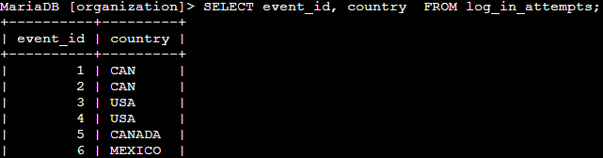

1. Write a SQL query that selects the username, login_date, and login_time columns from the log_in_attempts table.

SELECT username, login_date, login_time FROM log_in_attempts;

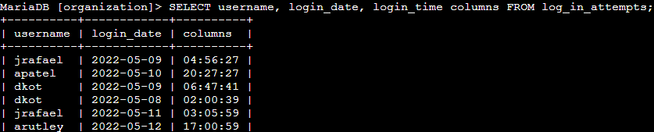

1. Write a SQL query that selects all columns from the log_in_attempts table, using a single symbol after the SELECT keyword.

SELECT * FROM log_in_attempts;

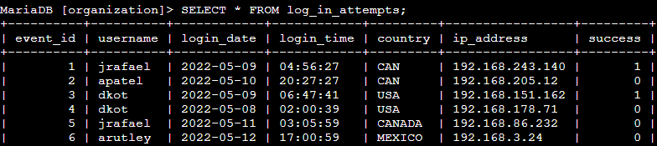

## 

## 

## **Task 3. Order login attempts data**

In this task, you need to use the ORDER BY keyword. You'll sequence the data that your query returns according to the login date and time.

**First**, you need to sort the information by date.

1. Run the following query, which orders log_in_attempts data by login_date:

SELECT *

FROM log_in_attempts

ORDER BY login_date;

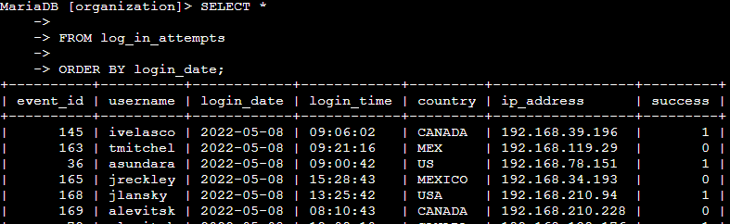

**Now**, you need to further organize the previous results by ordering them by login_time.

1. Modify the query from the previous step by adding the login time to the ORDER BY clause. You must replace X with the appropriate column name:

SELECT *

FROM log_in_attempts

ORDER BY login_date, X;

SELECT *

FROM log_in_attempts

ORDER BY login_date, login_time;

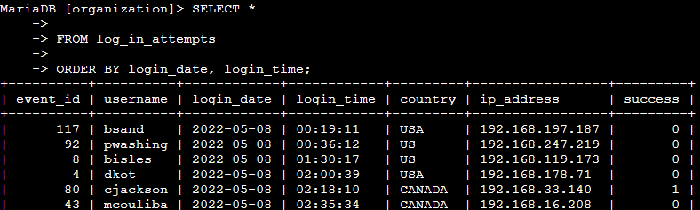

## **Conclusion**

I have completed this activity, and I now have practical experience in running basic SQL queries to

* select specific columns from a table,
* select all columns from a table by using an asterisk (*), and
* sort query results using the ORDER BY keyword.

These basic queries form the foundation for running more advanced queries and applying filters later.